# Step by Step Installing Tableau For Students

Go to the following link <https://www.tableau.com/academic/students>

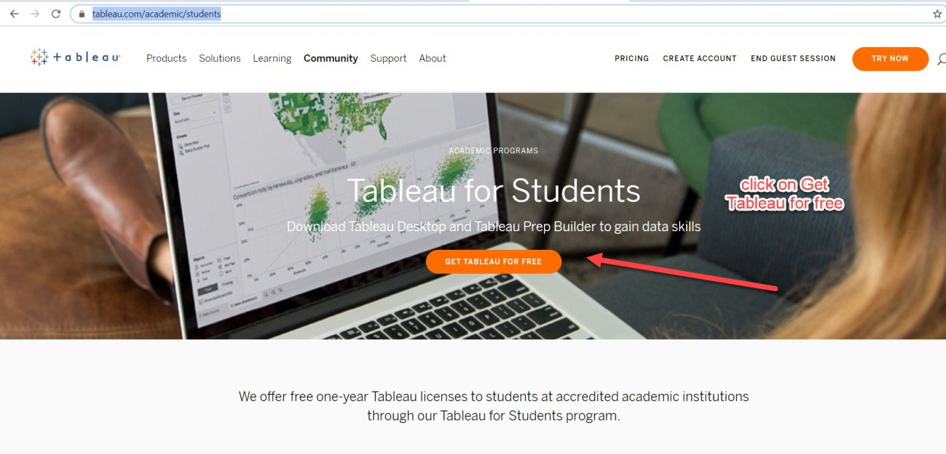

Fill in the form below

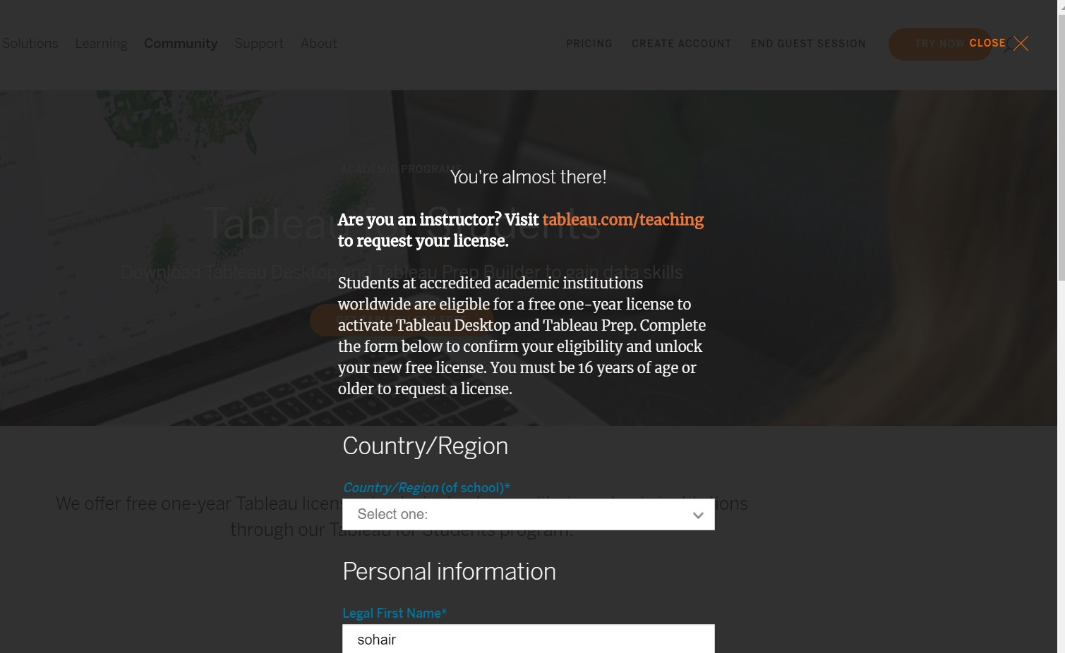

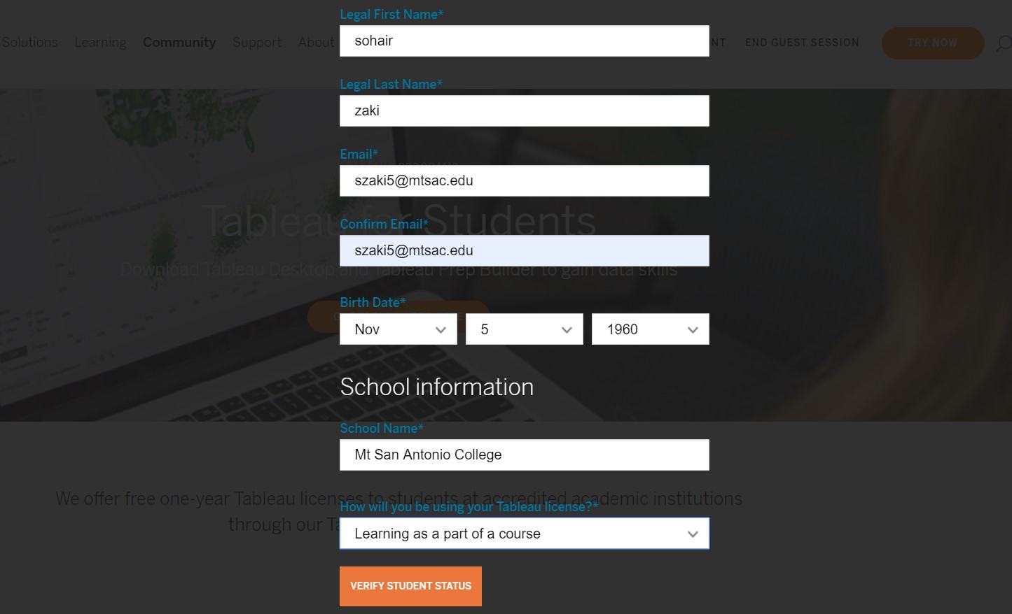

Click “verify student status” button .

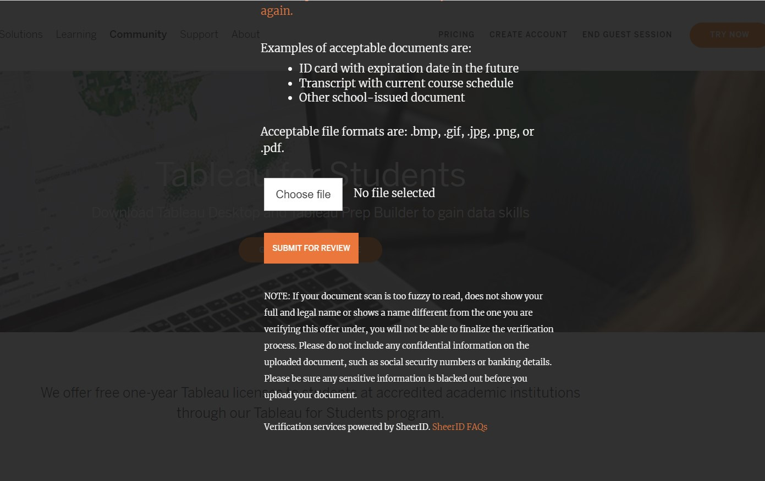

Please upload your student ID and all the required documents.

Please do that asap. It will take time to verify your status. We want tableau desktop and prep on your computers prior to Feb 25.

Email from Tableau team

Hi Sohair Zaki,

Thank you for your interest in the Tableau for Teaching program. Below is a website (landing page link) for your upcoming class. Each student should go to the landing page to download Tableau Desktop and enter the product key noted below. This key will allow your entire class to activate Tableau Desktop for the duration of the course.

Please forward these instructions to your students:  
**Big Data Integration CISD42**

1. [Download the latest version of Tableau Desktop and Tableau Prep Builder here](https://nam12.safelinks.protection.outlook.com/?url=https%3A%2F%2Fwww.tableau.com%2Ftft%2Factivation&data=04%7C01%7Cszaki5%40mtsac.edu%7C9b668f5b94734259355508d8b67b4578%7Ccc4d4bf20a9e4240aedea7d1d688f935%7C0%7C0%7C637459987852061664%7CUnknown%7CTWFpbGZsb3d8eyJWIjoiMC4wLjAwMDAiLCJQIjoiV2luMzIiLCJBTiI6Ik1haWwiLCJXVCI6Mn0%3D%7C1000&sdata=3fBJixo1%2Fn5E7suFwTGZBcVOv%2BrycEHtNHDYMA%2BVIkY%3D&reserved=0)
2. Click on the link above and select “Download Tableau Desktop” and “Download Tableau Prep Builder”. On the form, enter your school email address for Business E-mail and enter the name of your school for Organization.
3. Activate with your product key:  TCDM-9C90-7BC0-DC27-FF42
4. Already have a copy of Tableau Desktop installed? Update your license in the application: Help menu → Manage Product Keys

Are your students new to Tableau? Share our free [Data Analytics for University Students guide](https://nam12.safelinks.protection.outlook.com/?url=https%3A%2F%2Fwww.tableau.com%2Funiversity-students&data=04%7C01%7Cszaki5%40mtsac.edu%7C9b668f5b94734259355508d8b67b4578%7Ccc4d4bf20a9e4240aedea7d1d688f935%7C0%7C0%7C637459987852071620%7CUnknown%7CTWFpbGZsb3d8eyJWIjoiMC4wLjAwMDAiLCJQIjoiV2luMzIiLCJBTiI6Ik1haWwiLCJXVCI6Mn0%3D%7C1000&sdata=xAILaCqQtckFK3CAyFcQkY2ts52ovWE8fhqlB6Szlcs%3D&reserved=0) to help them get started.

Students can continue using Tableau after the class is over by individually requesting their own one-year license through the [Tableau for Students program here](https://nam12.safelinks.protection.outlook.com/?url=http%3A%2F%2Ftableau.com%2Fstudents&data=04%7C01%7Cszaki5%40mtsac.edu%7C9b668f5b94734259355508d8b67b4578%7Ccc4d4bf20a9e4240aedea7d1d688f935%7C0%7C0%7C637459987852071620%7CUnknown%7CTWFpbGZsb3d8eyJWIjoiMC4wLjAwMDAiLCJQIjoiV2luMzIiLCJBTiI6Ik1haWwiLCJXVCI6Mn0%3D%7C1000&sdata=iJqNiICrxJk0KkLVSGsbk3rgIJAkxthRch4JJ3lCuho%3D&reserved=0).

Additionally, all instructors are eligible to receive a Tableau Online site, which can be requested at [www.tableau.com/academic/teaching](https://nam12.safelinks.protection.outlook.com/?url=https%3A%2F%2Fwww.tableau.com%2Facademic%2Fteaching&data=04%7C01%7Cszaki5%40mtsac.edu%7C9b668f5b94734259355508d8b67b4578%7Ccc4d4bf20a9e4240aedea7d1d688f935%7C0%7C0%7C637459987852081578%7CUnknown%7CTWFpbGZsb3d8eyJWIjoiMC4wLjAwMDAiLCJQIjoiV2luMzIiLCJBTiI6Ik1haWwiLCJXVCI6Mn0%3D%7C1000&sdata=Z9i%2BNderxDFovb%2Bh%2F%2FSsxY8bVYWlhC4Y6j79UWZEb6o%3D&reserved=0). This will give you and your students access to our cloud product and will make sharing and collaboration far easier, especially when learning remotely.

Need help? Find answers to frequently asked questions [here](https://nam12.safelinks.protection.outlook.com/?url=https%3A%2F%2Fcommunity.tableau.com%2Fdocs%2FDOC-10249&data=04%7C01%7Cszaki5%40mtsac.edu%7C9b668f5b94734259355508d8b67b4578%7Ccc4d4bf20a9e4240aedea7d1d688f935%7C0%7C0%7C637459987852091583%7CUnknown%7CTWFpbGZsb3d8eyJWIjoiMC4wLjAwMDAiLCJQIjoiV2luMzIiLCJBTiI6Ik1haWwiLCJXVCI6Mn0%3D%7C1000&sdata=Y8h%2FvU48HiWSeKrQ1EGLPfJegoEiQNx9SxlsBc%2BSbDc%3D&reserved=0).

If you have any feedback on how we can best support you and your students during this time, please let us know!

Best,

Academic Programs Team  
Tableau Software  
[tft@tableau.com](mailto:tft@tableau.com)